SMART WASTE MANAGEMENT SYSTEM FOR METROPOLITAN CITIES
- By,
C. Gunasekaran
J. Kalistroedwin
M. Jagathesh
U. Keshavan.

ABSTRACT:
Waste Management is the most challenging issue of modern society. Fast growth in population, increased factory presence and modern lifestyle have contributed towards the large amount of waste. An efficient waste management system mainly revolves around waste segregation and processing. We hope our Waste Management System will handle this issue in perfect manner. This is one of best solution for keeping INDIA clean. The prototype of the proposed system is developed using Raspberry Pi Controller, website to govern the entire process with comfort and simplicity. The most important part of the proposed system is the sensory unit which helps in identifying different types of waste (Plastic, Waterbottles, Glasses, etc). The module contains Cameras for Identifying object so as to categorize different categories of waste. The major units of the module consist of four noticeable components such as Camera, IR sensor, DC motor and Cash dispenser. While the waste management is performed at the software system, first the object is identified by the camera then identified the exact name object then information is shared to processor and to cash dispenser unit. According to the output of processor (Raspberry Pi) the cash will be delivered. If the garbage reaches the maximum limit, the IR sensor will detect it and sends alert to the processing unit (Raspberry Pi). After the information (Dustbin filled) shared to respective department using GSM.
The location is identified by GPS. The major difference in our project is at the end of process people will receive cash or coin according to the type, quantity of garbages that is put it into the machine. This quantity and other metadata of the collected waste is monitored and will be dispatched by the respective department.

INTRODUCTION:
WASTE MANAGEMENT SYSTEM IN INDIA:
Waste management in India falls under the purview of the Union Ministry of Environment, Forests and Climate Change (MoEF&CC). In 2016, this ministry released the Solid Wastage Management (SWM) Rules, which replaced by the Municipal Solid Waste (Management and Handling) Rules, and 2000 of which had been in place for 16 years. This national policy plays a significant role in the acknowledgement and inclusion of the informal sector (waste pickers) into the waste management process for the first time.
India generates 62 million tonnes of waste each year. About 43 million tonnes (70%) are collected, of which about 12 million tonnes are treated, and 31 million tonnes are dumped in landfill sites
With changing consumption patterns and rapid economic growth, it is estimated that urban municipal solid waste generation will increase to 165 million tonnes in 2030.
But In India:
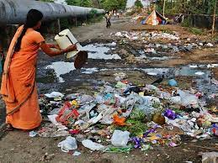
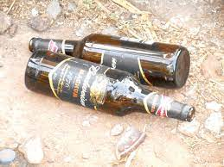
In Other Countries:

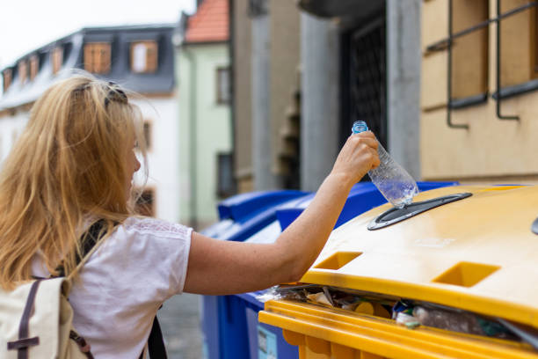
To overcome these different between India and other countries here our project will help us little bit to keep INDIA clean.
NEED FOR IMPROVEMENT IN WASTE MANAGEMENT SYSTEM:
- Nearly two-thirds of the world's population will reside in urban areas by 2030. This reality necessitates the development of sustainable urban lifestyle solutions, as waste management is a major health concern.
- The needs of future cities include efficient and energy-saving waste management, lowering CO2, air pollution, and vehicle exhaust emissions, to name just a few. Given such, it becomes increasingly crucial to use resources responsibly and efficiently.
- In wealthy nations, efficient waste management is crucial. Even though waste management only benefits a small portion of the population, it can consume up to 50% of a city's budget.
- Up to 60% of rubbish is occasionally not collected; instead, it is frequently just burned along the highway. It can contaminate drinking water and spread illness among people.
FEATURES OF HAVING SMART WASTE MANAGEMENT SYSTEM:
- The intelligent, sensor-based trash can will assess the amount of rubbish inside and send a message right to the municipal organisation.
- It is capable of detecting all types of waste, whether they are solid or liquid.
- With the aid of the "TRANSPORTATION SOFTWARE," municipal corporation vehicles will select the quickest route based on the amount of dustbin fill, saving them time.
- It highlights "DIGITAL INDIA" and uses a straightforward system. If there is ever a problem with any equipment in the future, that component can be quickly and easily replaced with a new one.
ADVANTAGES OF SMART WASTE MANAGEMENT SYSTEM:
- A reduction in time and fuel use because vehicles only travel to fully loaded containers; a reduction in noise, traffic, and air pollution because there are fewer trucks on the road.
- Our sophisticated operating system enables two-way communication between the service provider and the trash cans placed across the city. As a result, the collection of the containers' fill levels based on the route is the only area of concentration.
- The sensors that have been installed in the containers offer real-time data on the fill level.
- The timing and location of collection priorities can be determined using this information.
- In this approach, a system that is optimised results in significant cost savings and less urban pollution, which benefits both service providers and citizens.
- Lowers the service's infrastructure (trucks, containers), operating (fuel), and maintenance expenses by up to 30%.
- By implementing this technology, the city may manage its resources, costs, and management more effectively, becoming a "SMART CITY."
- Historical data on collections aids in tailoring container deployment to the real demands of the city, resulting in fewer containers clogging the streets and more public parking spaces.
- Reducing the amount of labour needed to manage rubbish collection. It keeps the surroundings clean and green, free of unpleasant waste odours, stresses a healthy atmosphere, and keeps cities more attractive.
APPLICATIONS OF SMART WASTE MANAGEMENT SYSTEM:
- Municipal corporations can use this to improve their management of waste collection the best.
- The right technology (GPS & SOFTWARE APPLICATIONS) can assist us direct vehicles to choose the shortest route.
- Additionally, it supports "DIGITAL INDIA" and the "SMART CITY" initiative.
MAJOR COMPONENTS THAT WE ARE USED HERE IS:
1. Garbage container:
Rubbish containers are typically made of metal or plastic and are used to temporarily store waste.
There are typically three different types of curbside trash cans: trash cans (metal or plastic containers), dumpsters (huge containers akin to skips), and wheelie bins (light, usually plastic bins that are mobile). All of them are emptied by collectors, who then load the contents into a garbage truck and take it to a disposal site like a landfill, an incinerator, or a crushing plant for consumption.
2. Ultrasonic sensor:
The ultrasonic proximity sensors employ a unique sonic transducer that enables alternate sound wave transmission and reception. The transducer emits sound waves, which are reflected by an object and returned to the transducer. The ultrasonic sensor will switch to receiving mode after it has finished emitting the sound waves. The distance of the item from the sensor determines how long it takes for an emission to be followed by a reception.
Ultrasonic sensors generate high-frequency sound waves and
evaluate the echo which is received back by the sensor, measuring the time interval between sending the signal and receiving the echo to determine the distance to an object.
3.Arduino board:
In order to create digital devices and interactive objects that can sense and control physical items, Arduino is a software firm, project, and user community that develops and produces computer open-source hardware, open-source software, and microcontroller-based kits .
The project is based on designs for microcontroller boards made by a number of suppliers utilising different microcontrollers. A variety of expansion boards (also known as shields) and other circuits can be interfaced with these systems' sets of digital and analogue I/O pins. For loading software from personal computers, the boards provide serial communication ports, some of which include Universal Serial Bus (USB). The Arduino project offers an integrated development environment (IDE) for microcontroller programming that is based on the Processing programming language and additionally supports C and C++.
The Arduino IDE supports the languages C and C++ using special rules to organize code.

4. GSM:

Numerous carrier frequency bands (divided into GSM frequency bands for 2G and UMTS) are used by GSM networks for their operation.

Most 2G GSM networks operate in the 900 MHz or 1800 MHz frequency bands for 3G. The 850 MHz and 1900 MHz bands were utilised instead of these bands where they were already allotted (for instance, in Canada and the US). Rarely, some nations award the 400 and 450 MHz frequency bands because those ranges were previously occupied by first-generation systems.

5.Bread board:
The solderless breadboard is reusable because soldering is not necessary. This makes it simple to utilise for developing temporary prototypes and conducting circuit design experiments. Due to this, solderless breadboards are also very well-liked by students and are often used in technology education. Earlier breadboard models lacked this characteristic. It is difficult to reuse a stripboard (veroboard) or other prototyping printed circuit board, which is used to create one-off or semipermanent soldered prototypes. Breadboards can be used to prototype a wide range of electronic systems, from tiny analogue and digital circuits to full-fledged central processing units (CPUs).

6. Jumper wires:

For solderless breadboarding, jump wires (also known as jumper wires) can be purchased in ready-to-use jump wire sets or made manually. For bigger circuits, the latter can become laborious work. Jumper wires that are ready to use come in a variety of qualities, some of which even include teeny plugs on the wire ends. If no tiny plugs are to be affixed to the wire ends, jump wire material for commercially available or home-made wires should typically be 22 AWG (0.33 mm2) solid copper, tin-plated wire. Strip the wire ends from 3/16 to 5/16 in (4.8 to 7.9 mm). Shorter stripped wires run the risk of making poor contact with the spring clips on the board (insulation getting tangled in the springs). Short-circuits on the board are more likely to occur with longer stripped wires. When inserting or withdrawing wires, jump wire pliers and tweezers are in handy, especially on packed boards.

Circuit Connection:

But this project doesn’t work properly. So we can’t provide circuit.

Block diagram:

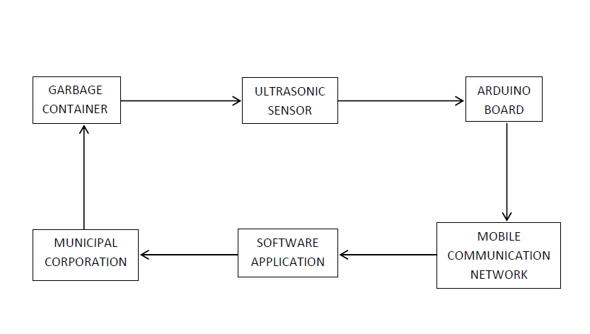

Source code:

https://github.com/IBM-EPBL/IBM-Project-35221-1660282887
link for source code.

Required cost to complete projects:
Extra charges may become.

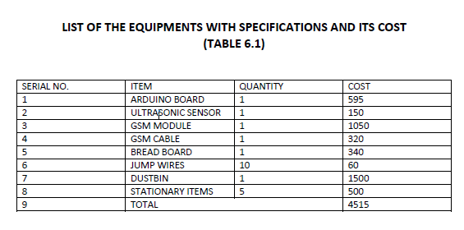

LITERATURE SURVEY:
[1] Author: Theodoros Vasileios Anagnostopoulos (2014)
He have proposed a useful garbage collection through shortest path semi static and dynamic routing for controlling traffic that is created by the trucks which carrying the waste. Here they have used two layers, in which upper layer is semi static shortest path routing model. This layer contains the waste collection terrain for each city sector. Lower layer dynamic shortest path routing model handles the dynamic requirements of real time routing in case of emergency. Waste routing was achieved by the Ant colony system algorithm (ACS), in turn to group the garbage bins allocation in the form of clusters, they have used K-means algorithm. By using above mechanisms the authors effectively measured distance covered, time spent, fuel consumption and the quantity of solid waste collected. They have mentioned the future work will be in the area of time critical scheduling, where once the waste bins are full and need to be emptied at the earliest by available waste collecting vehicles.
[2] Author: Theodoros Vasileios Anagnostopoulos and Arkady Zaslavsky, Alexey Medvedev, Sergei Khoruzhniov (2015)
He have illustrated the Top-k query based dynamic scheduling for smart city garbage collection. They introduced Top-k query to denote the number of filled bins in turn to begin dynamic scheduling. Authors have used adaptive large neighborhood search algorithm to determine the cost optimal routes for the trucks to empty the bins. They used roll on-roll off routing mechanism to help several dumping services to collect large amount of garbage from the location of shopping malls and construction sites. The demerit of this model is, in dynamic scheduling depending on the k-value, CPU overhead cost is high. The future work they mentioned is dynamic routing model depends on fuzzy demands. Here the customer acts as variables of fuzzy.

[3] Author:-Theodoros Vasileios Anagnostopoulos and Arkady Zaslavsky, Alexey Medvedev (2015)
He describes the waste collection as a potential Internet of things service which exploits robustness and cost efficiency of a different types of fleets. Authors have used robust dynamic routing algorithm to find the shortest path, by this they achieved cost efficiency. They used Android app for truck navigation, GPS to track the truck location, RFID to identify the certain bins and actuators to lock the lid of the bin when bin gets full to avoid the overflow of the garbage. Here they used two types of trucks: High Capacity Trucks (HCT) to transport waste from depots to dump yard and Low Capacity Trucks (LCT) to transport waste from dump yard to depots.

[4] Author:- Martijn Mes, Marco Schutten , Arturo Perez Rivera(2014)
The authors aims at inventory routing for dynamic waste collection. Here they mainly focus on the problems of scheduling of emptying the containers and to take quick decision on selection of nearest route for the vehicles. By this the garbage collection costs can be minimized and at the same time customer satisfaction can also be improved. Here they used heuristic approach to deal with the dynamic and stochastic nature of the problem. Here they considered two policies viz. Sequential Kriging Optimization (SKO) and Hierarchical knowledge gradient (HKG). HKG quickly identify the optimization areas within the network space and then use SKO for communication.

[5] Author:- Parkash, Prabu(2015)
He have proposed a system, where multiple dustbins are located throughout the city. These dustbins are embedded with low cost devices and unique ID will be given for every dustbin in the city. This will help in tracking the level of garbage in each bin. In this system, these bins are connected to the internet to get the real time information of the smart bins. By implementing this system authors have achieved cost reduction, resource optimization, real time data transmission and effective use of smart dustbins. They have mentioned the future work as; the system can be implemented with time stamps.

Conclusion:

The collecting of rubbish in the city is made easier by employing this strategy. It aids in decreasing time, money, manpower, traffic, and air pollution. We can direct the trucks to choose the shortest route for garbage collection with the use of the appropriate technology (GPS & SOFTWARE APPLICATIONS). This idea could give communities that want to become smart and hospitable to people an advantage.

REFERENCE
[1] Theodoros Vasileios Anagnostopoulos and Arkady Zaslavsky, “Effective waste collection with shortest path semi-static and dynamic routing.” LNCS vol.8638, pp. 95-105, Springer (2014).

[2] Theodoros Vasileios Anagnostopoulos and Arkady Zaslavsky, Alexey Medvedev, Sergei Khoruzhniov, “Top-k Query based dynamic scheduling for IOT-enabled smart city waste collection .” International conference on mobile data management (ICMDM)(2015):50-55.

[3] Theodoros Vasileios Anagnostopoulos and Arkady Zaslavsky, Alexey Medvedev, “Robust waste collection exploiting cost efficiency of IOT potentiality in smart cities.” International conference on recent advances in internet of things (ICRIOT)(2015):7-9.

[4] Martijn Mes, Marco Schutten , Arturo Perez Rivera, “Inventory routing for dynamic waste collection.” Elsevier (2014):1-4.

[5] Parkash, Prabu. v, “IOT based waste management for smart city.” International journal of innovative research in computer and communication engineering (IJIRCCE) (2015):vol.4 ,issue 2.

